Steps of Installation :

1. Creating New Project and Installing Django :
2. First Create A folder named MusicPlayer
3. Opened it in pycharm ide
4. In terminal run Django-admin for all Django commands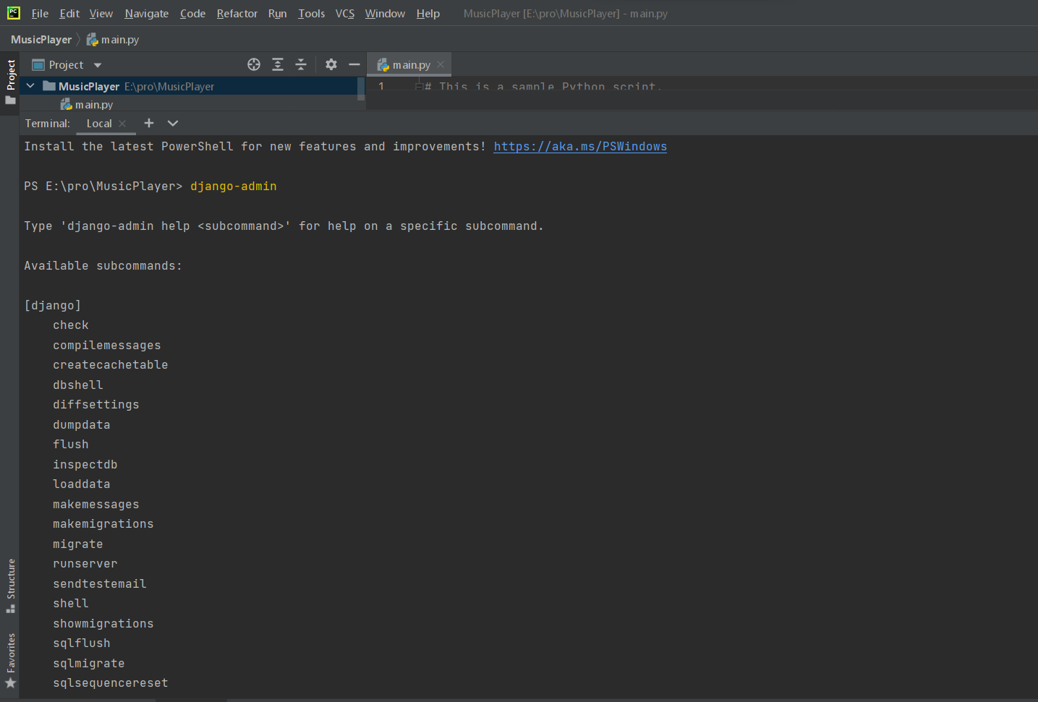
5. Then Create a New Project named Mp
6. Then change path to Mp and create 2 app Named home and musicplayer
7. And run the local server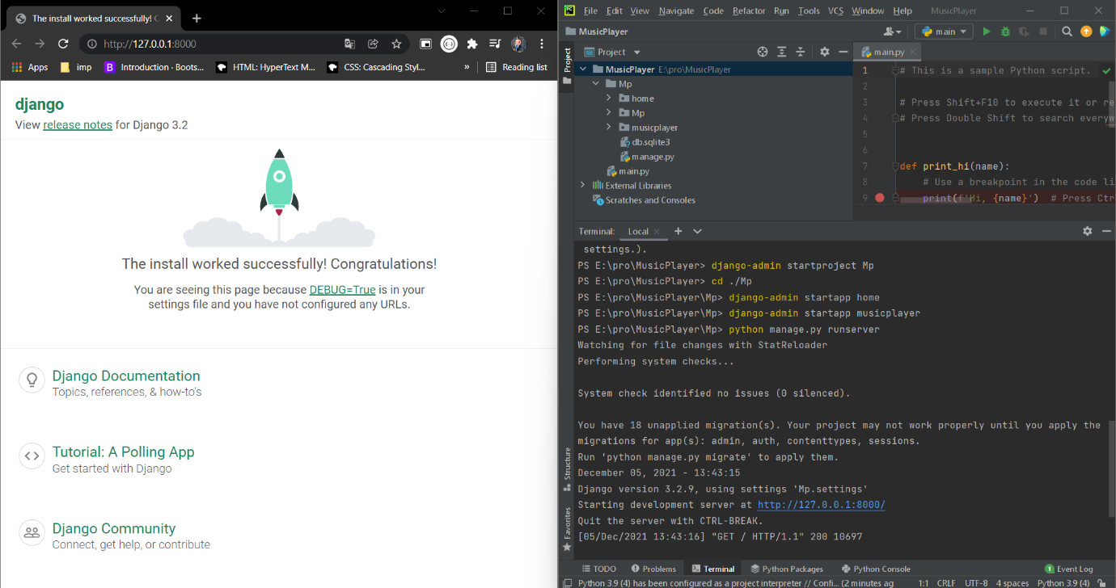
8. Creating New Database:
9. The main Task is to create database
10. But Django provide us the Django own database
11. Create two database: 1.Music db-to store song and coverimgs and 2.contacts-to store queries from users

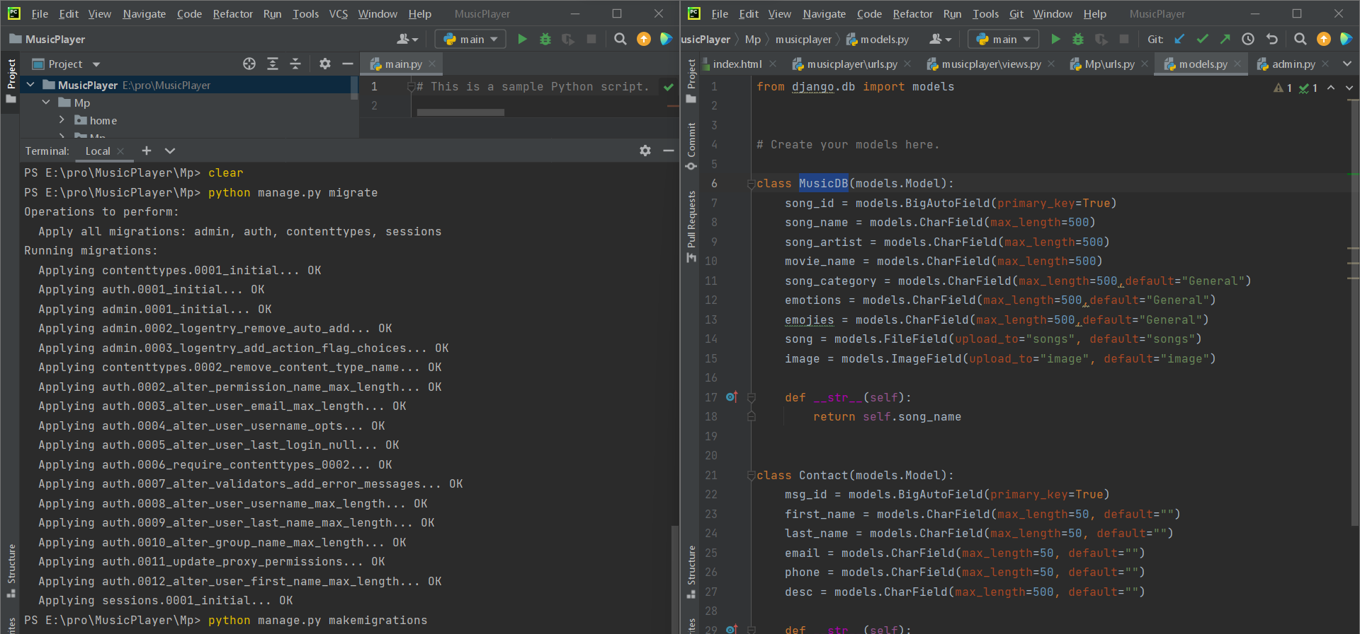

3.Creating Static Folder And Load Media:

1. To save the background images and songs we give media root for the project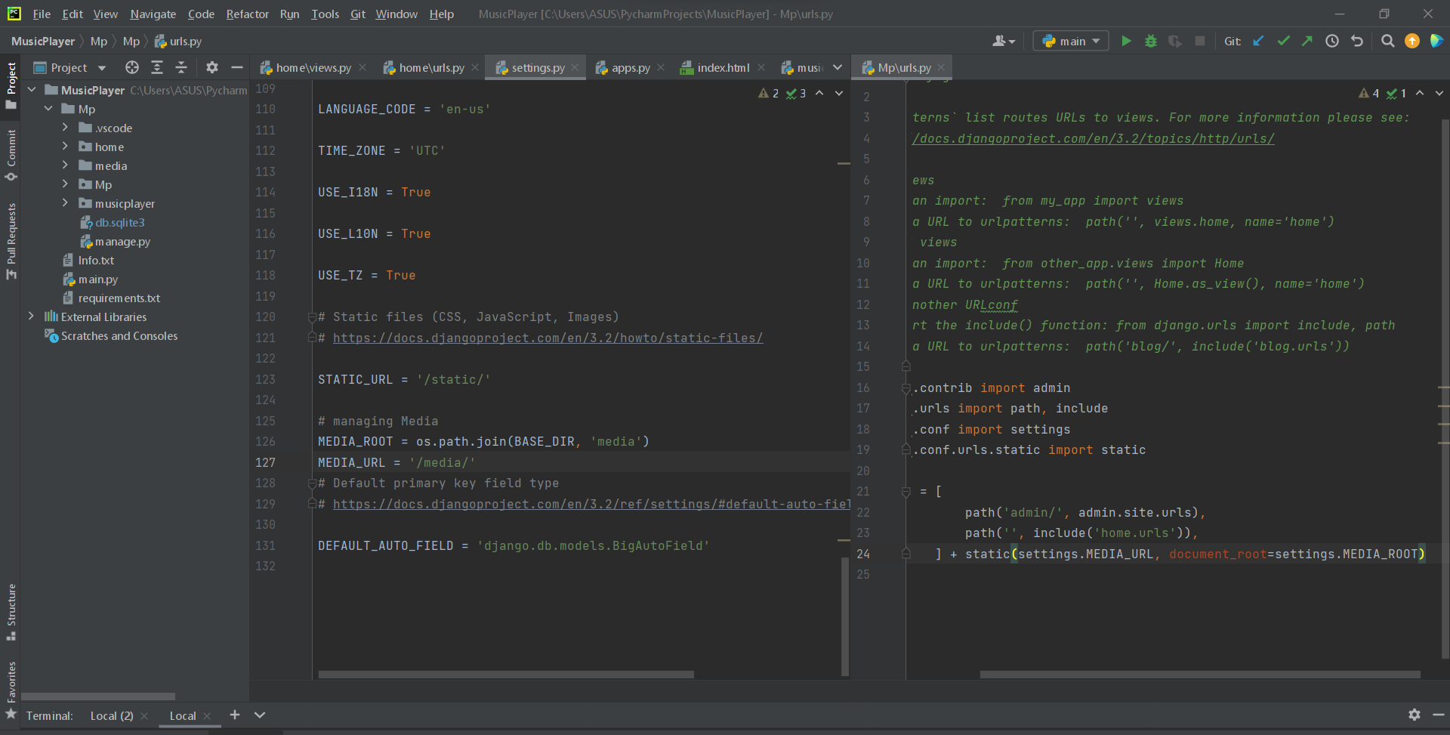

4.Registeration of apps in settings.py of project:

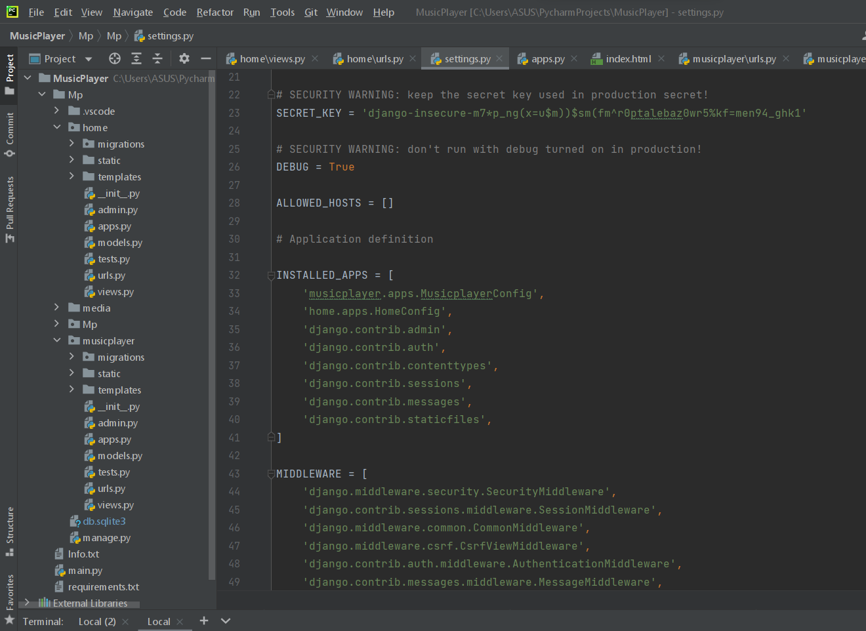

5.Creating URL pipeline throughout the project:

The flow of Django web app is manage.py --> settings.py 🡪 urls.py(Mp)🡪

Urls.py(home) 🡪 urls.py(musicplayer)

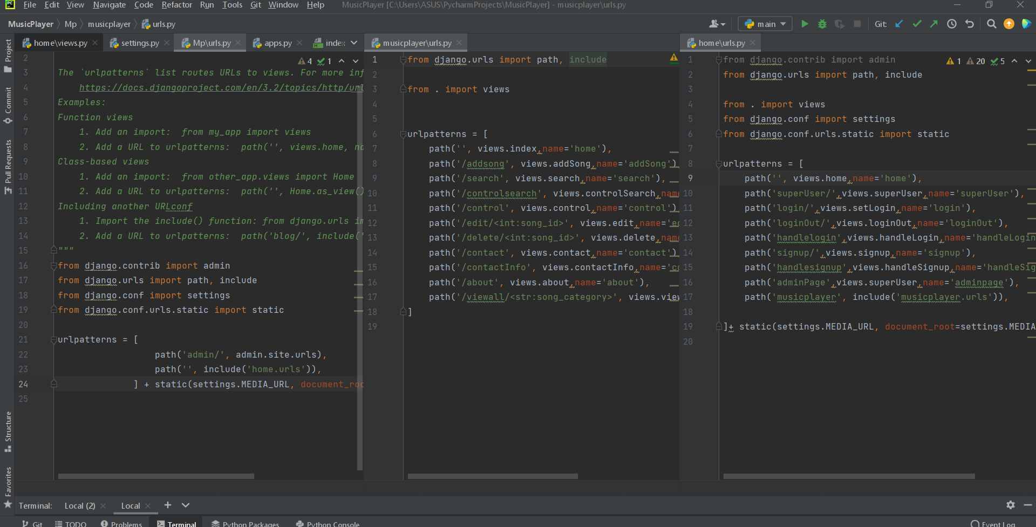

6. Creating views.py folder of webapp:

a) views.py(home) :-

i) views.py of home handles account less user(not logged in)

ii) it handles log in and sign up pages

iii) And also handles log in of superuser(admin)

b) views.py(musicplayer) :-

i) it handles actual home page having song windows

ii) it handles log in of superuser(admin)

iii) some main features control by admin

1. Addsongs
2. Songs control panel
3. Edit songs
4. Delete songs
5. Control page for contact
6. Push admin in apps home page
7. Search songs in control panel by admin

iv) some features for users like

1. View all songs of same category
2. Search
3. Search via emoji
4. Logout
5. Contact page
6. About page

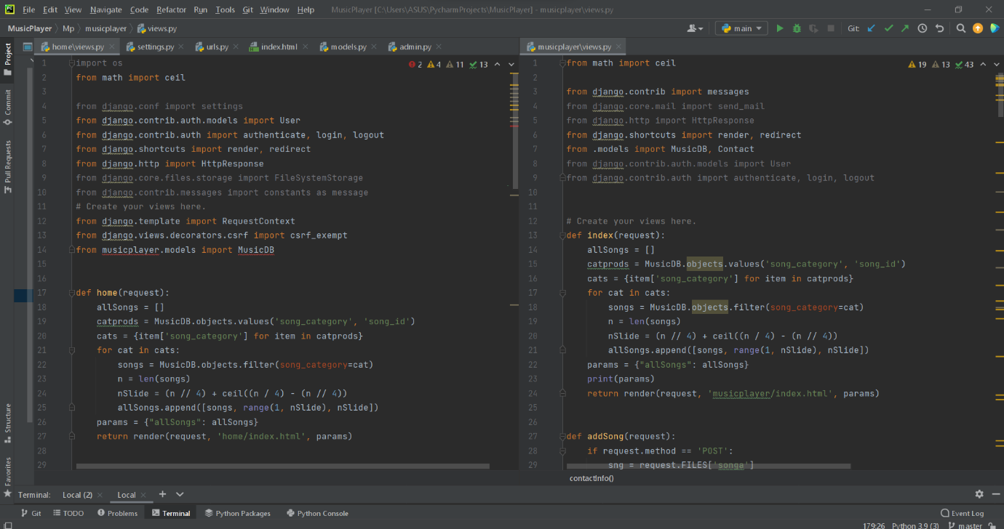

7 Creating Template folder for the html page :

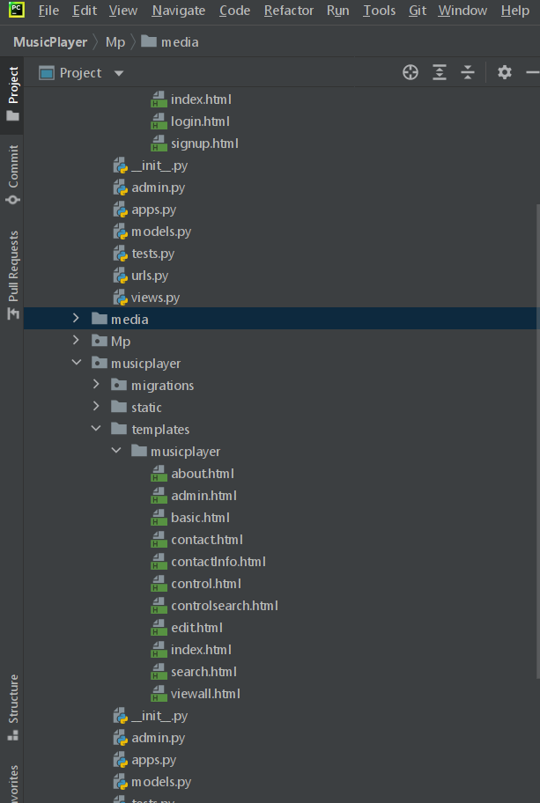

8) Key Features of Webapp :

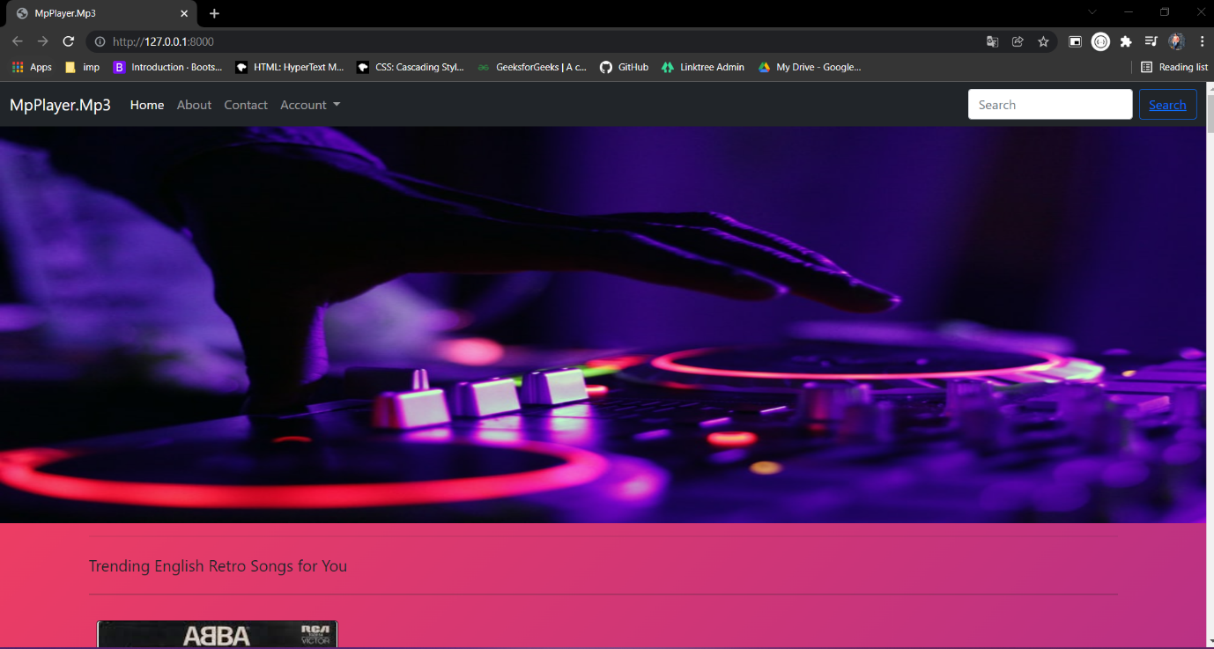

Home page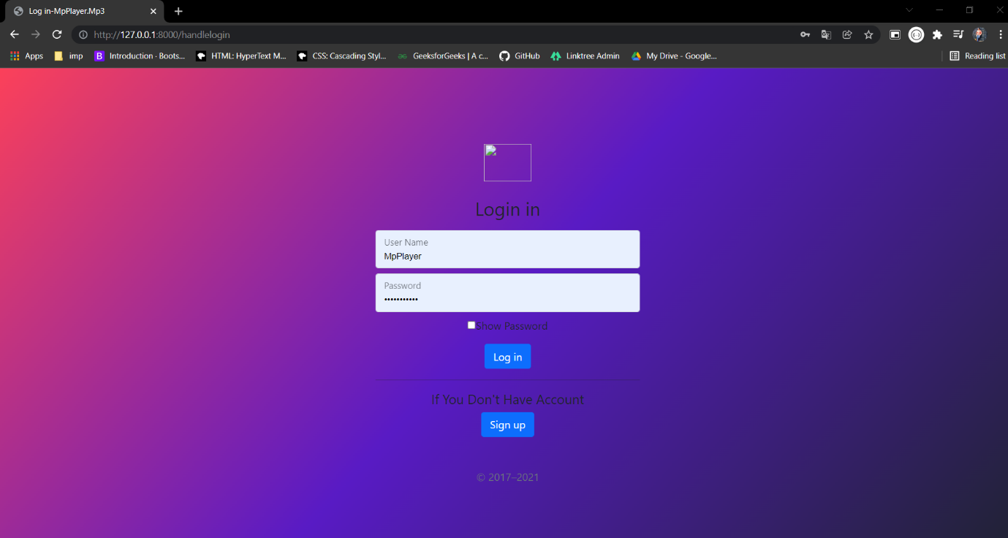Log in page

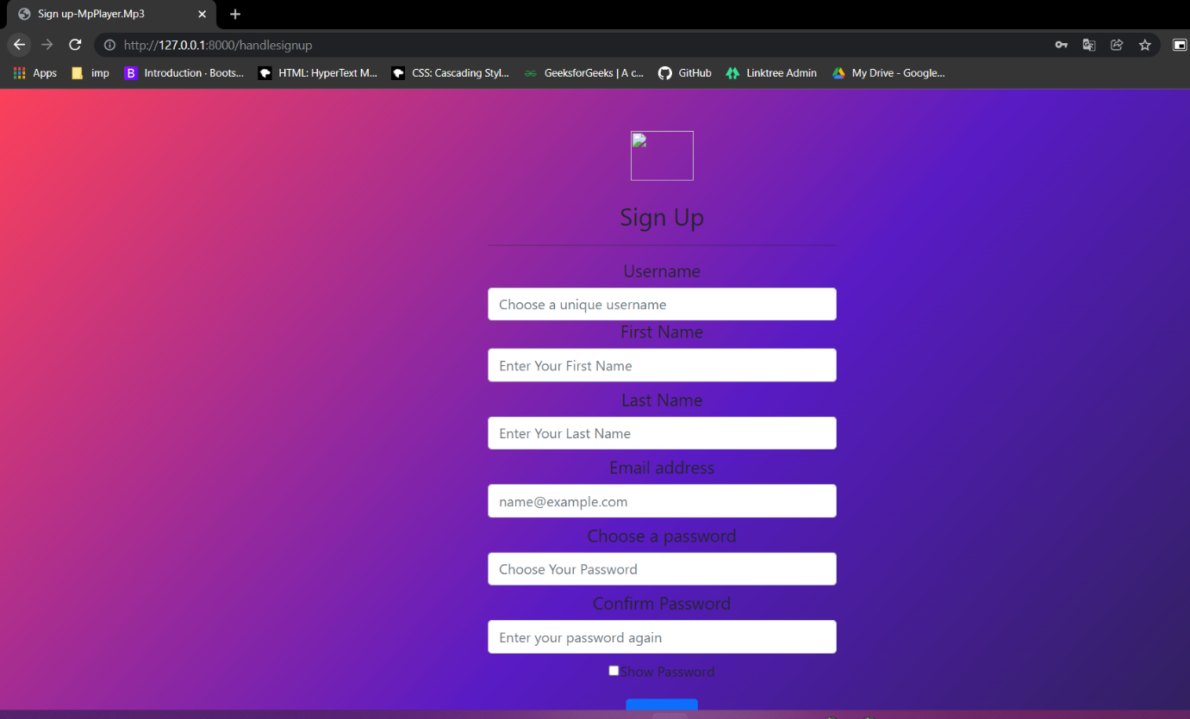Sign up page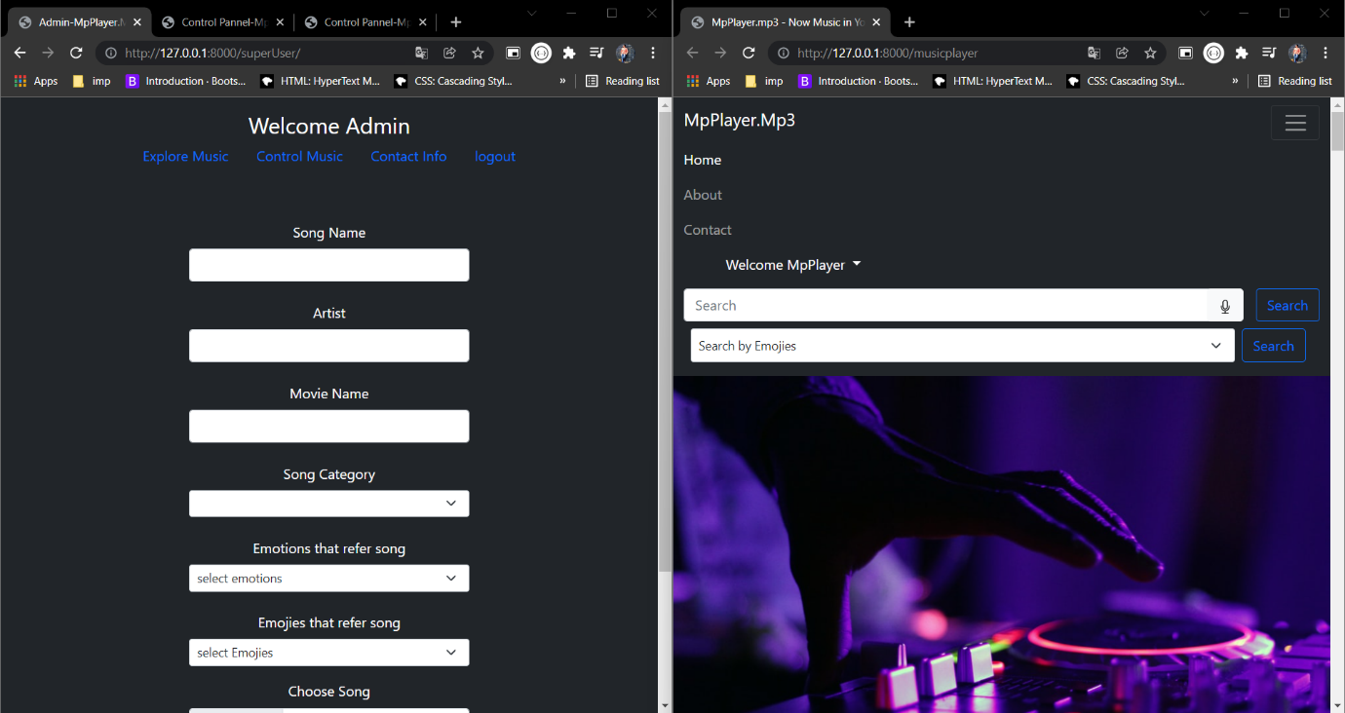Add Song page and Login via Admin

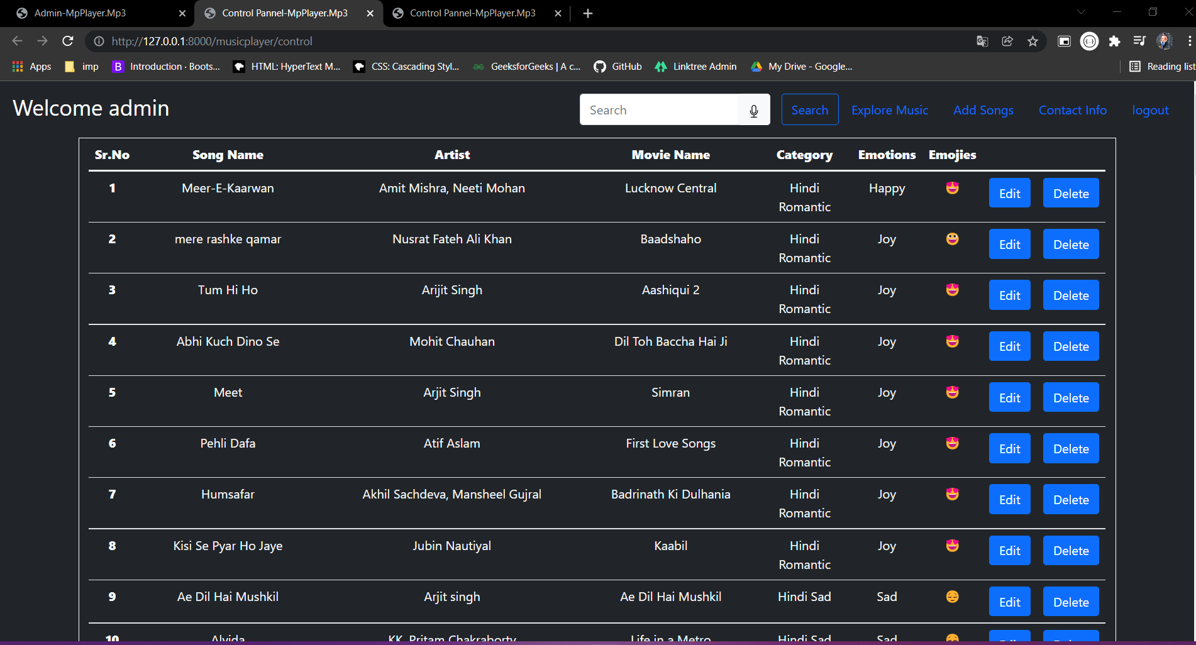Control panel for Songs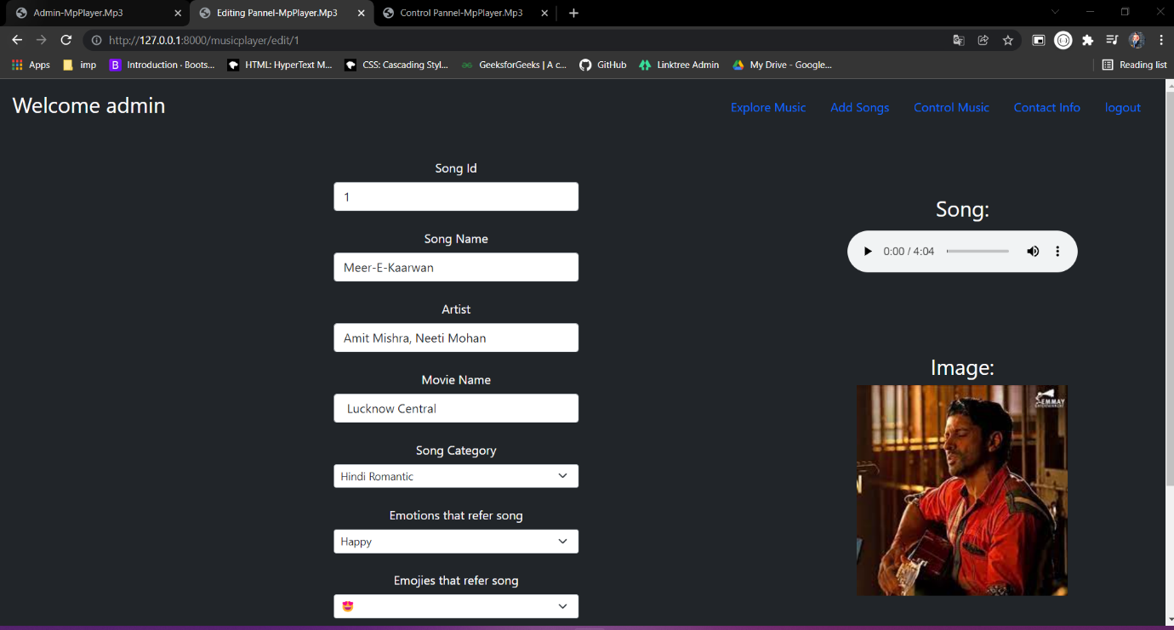Edit page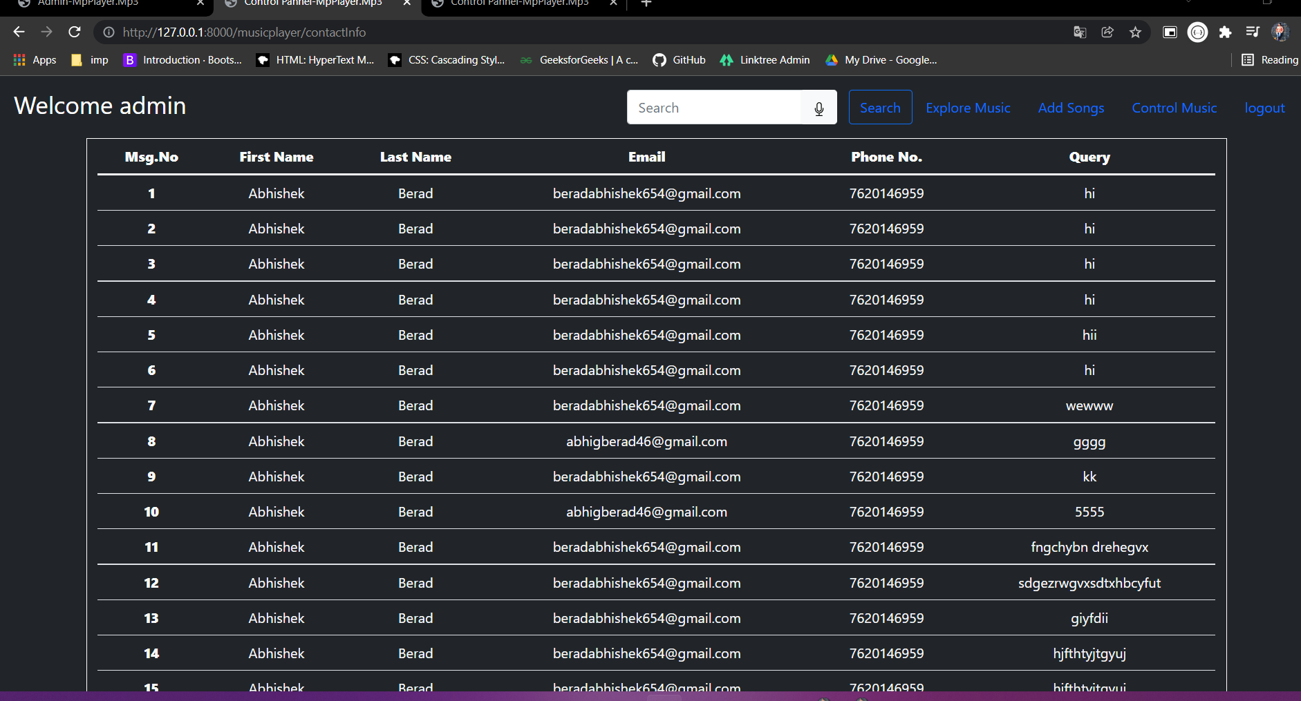Control Page for Contact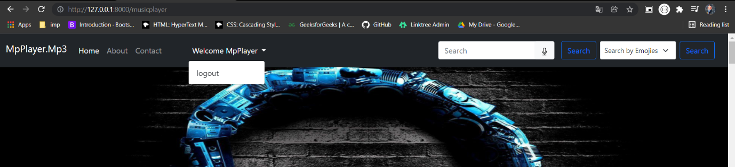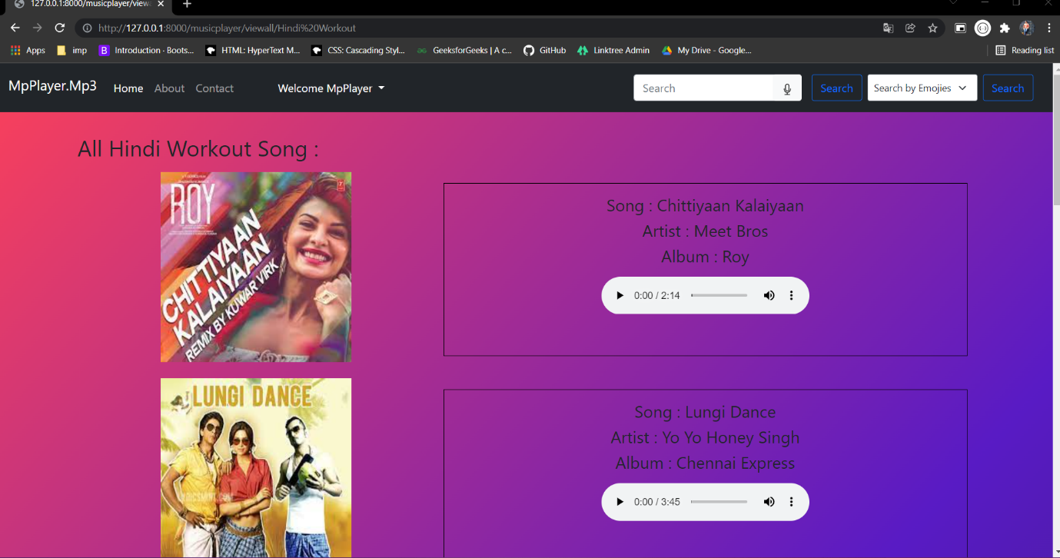View All Page through Category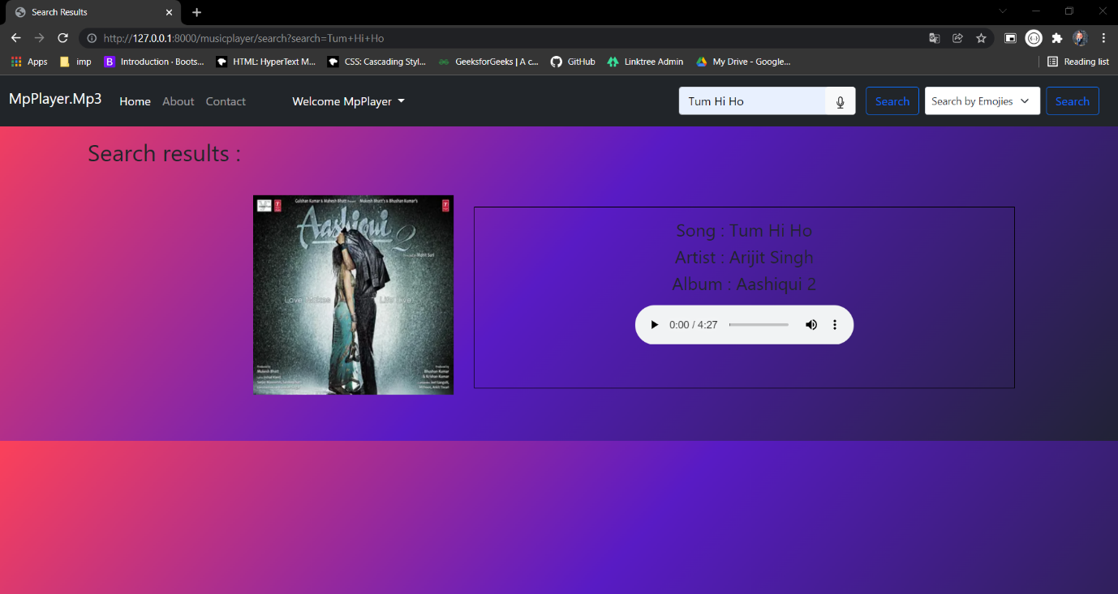

Search through normal search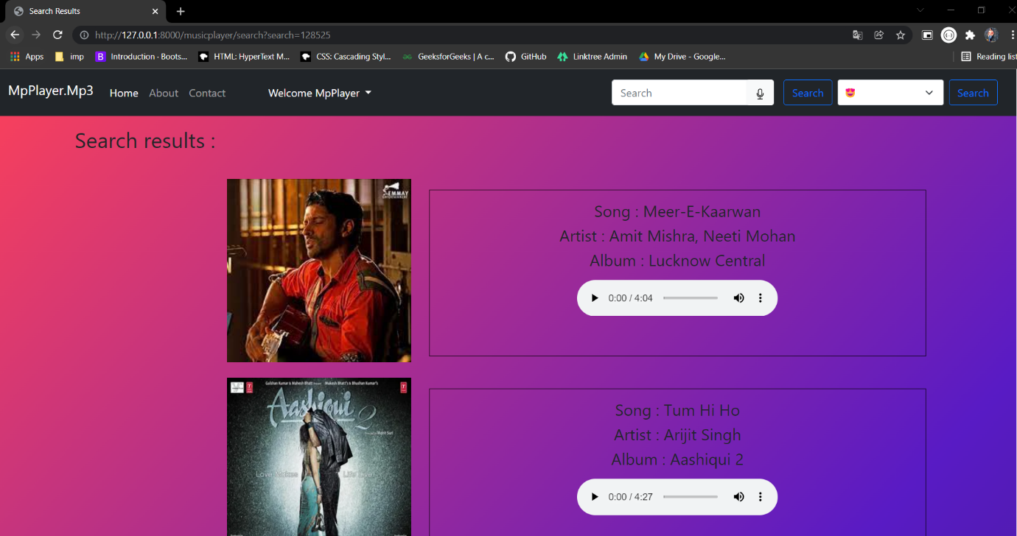 Search through Emoji search